OS Lab Report – Week 8 & 9

Producer - Consumer Problem

PES1201800366

Aditeya Baral

**1. Week 8**

Write a C program to implement Producer Consumer problem using Semaphores.

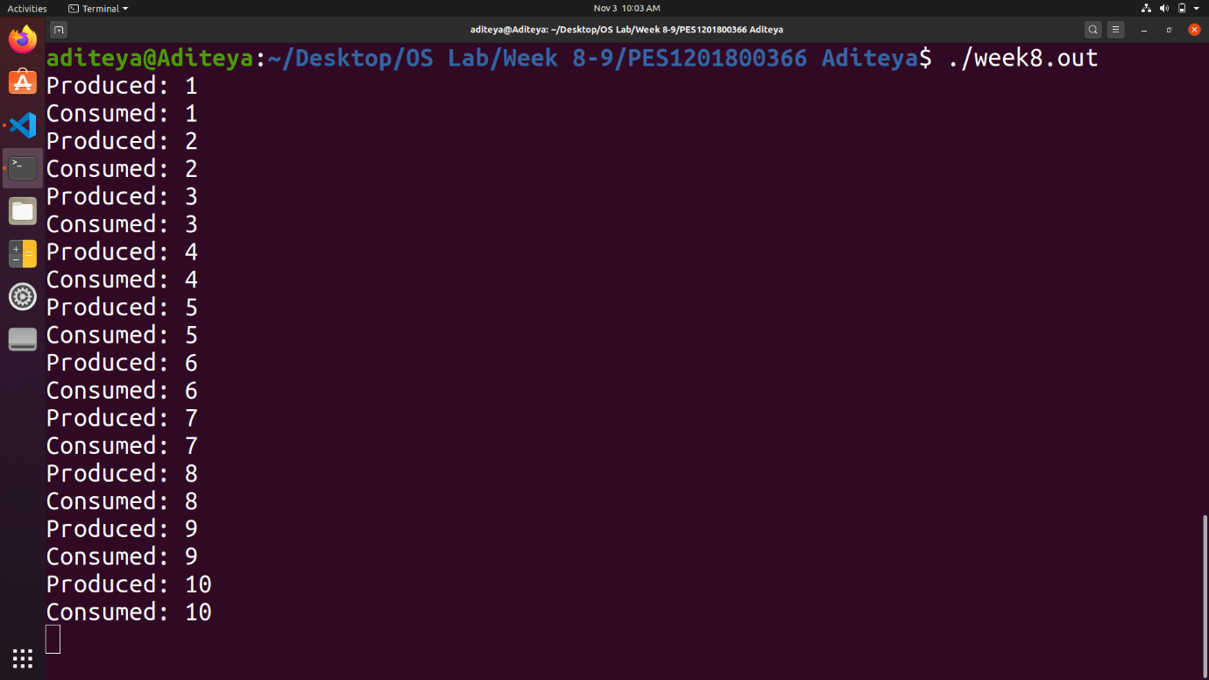

**2. Week 9**

Write a C program to implement Producer Consumer problem using Pipes.

